AML Notes
APRIORI ALGORITHIM CODE

import pandas as pd
from mlxtend.frequent_patterns import apriori, association_rules #association rules bnata ha || apriori itemsets nikalta ha

data=[
['bread','milk'],
['bread','diaper','beer','eggs'],
['milk','diaper','beer','coke'],
['bread','milk','diaper','beer'],
['bread','milk','diaper','coke']
]

items=[]

for transaction in data:
for item in transaction:
if item not in items:
items.append(item)
items=sorted(items)
print(items)

rows = []

for transaction in data:

row = {}

for item in items:
row[item] = (item in transaction)

rows.append(row)

encoded_data = pd.DataFrame(rows)

frequent_itemsets=apriori(
encoded_data,
min_support=0.4,
use_colnames=True
)

rules=association_rules(
frequent_itemsets,
metric="confidence",
min_threshold=0.7
)

print(rules)

Deep Learning Neural Network
import pandas as pd
from sklearn.model_selection import train_test_split
from tensorflow.keras.models import Sequential
from tensorflow.keras.layers import Dense
from tensorflow.keras.optimizers import Adam

url = "https://raw.githubusercontent.com/jbrownlee/Datasets/master/pima-indians-diabetes.data.csv"

columns = [
'Pregnancies',
'Glucose',
'BloodPressure',
'SkinThickness',
'Insulin',
'BMI',
'DiabetesPedigreeFunction',
'Age',
'Outcome'
]

data = pd.read_csv(url, names=columns)

X = data.iloc[:, :-1]
Y = data.iloc[:, -1]

x_train, x_test, y_train, y_test = train_test_split(
X, Y,
test_size=0.2,
random_state=42
)

model = Sequential()

model.add(Dense(12, input_dim=8, activation='relu'))
model.add(Dense(32, activation='relu'))
model.add(Dense(1, activation='sigmoid'))

model.compile(
optimizer=Adam(learning_rate=0.001),
loss='binary_crossentropy',
metrics=['accuracy']
)

history = model.fit(
x_train,
y_train,
epochs=10,
batch_size=10,
verbose=1
)

loss, accuracy = model.evaluate(
x_test,
y_test
)

print("Accuracy:", accuracy)

CNN
# =========================
# 1. IMPORT LIBRARIES
# =========================
import tensorflow as tf
from tensorflow.keras import layers, models
from tensorflow.keras.preprocessing.image import ImageDataGenerator

# =========================
# 2. DATASET PATHS
# =========================
train_dir = "/content/drive/MyDrive/Train"
test_dir = "/content/drive/MyDrive/Test"

# =========================
# 3. DATA AUGMENTATION
# =========================
train_datagen = ImageDataGenerator(
rescale=1./255,
rotation_range=20,
zoom_range=0.2,
horizontal_flip=True,
validation_split=0.2
)

test_datagen = ImageDataGenerator(
rescale=1./255

# =========================
# 4. LOAD DATA
# =========================
img_size = (256, 256)
batch_size = 32

# Training set
training_set = train_datagen.flow_from_directory(
train_dir,
target_size=img_size,
batch_size=batch_size,
class_mode='binary',
subset='training'
)

# Validation set
validation_set = train_datagen.flow_from_directory(
train_dir,
target_size=img_size,
batch_size=batch_size,
class_mode='binary',
subset='validation'
)

# Test set (FINAL evaluation only)
test_set = test_datagen.flow_from_directory(
test_dir,
target_size=img_size,
batch_size=batch_size,
class_mode='binary'
)

# =========================
# 5. BUILD CNN MODEL
# =========================
model = models.Sequential()

model.add(layers.Conv2D(32, (3,3), activation='relu', input_shape=(256,256,3)))
model.add(layers.MaxPooling2D(2,2))

model.add(layers.Conv2D(64, (3,3), activation='relu'))
model.add(layers.MaxPooling2D(2,2))

model.add(layers.Conv2D(128, (3,3), activation='relu'))
model.add(layers.MaxPooling2D(2,2))

model.add(layers.Flatten())
model.add(layers.Dense(128, activation='relu'))
model.add(layers.Dropout(0.5)) # helps reduce overfitting
model.add(layers.Dense(1, activation='sigmoid'))

# =========================
# 6. COMPILE MODEL
# =========================
model.compile(
optimizer='adam',
loss='binary_crossentropy',
metrics=['accuracy']
)

# =========================
# 7. MODEL SUMMARY
# =========================
model.summary()

# =========================
# 8. TRAIN MODEL
# =========================
history = model.fit(
training_set,
epochs=10,
validation_data=validation_set
)

# =========================
# 9. EVALUATE ON TEST SET
# =========================
test_loss, test_acc = model.evaluate(test_set)
print("Test Accuracy:", test_acc)

# # =========================
# # 10. SAVE MODEL
# # =========================
# model.save("/content/drive/MyDrive/cat_dog_cnn_model.h5")

# # =========================
# # 11. PLOT RESULTS
# # =========================
# import matplotlib.pyplot as plt

# plt.plot(history.history['accuracy'], label='Train Accuracy')
# plt.plot(history.history['val_accuracy'], label='Validation Accuracy')
# plt.xlabel('Epoch')
# plt.ylabel('Accuracy')
# plt.legend()
# plt.show()

RNN (Recurrent Neural Network)
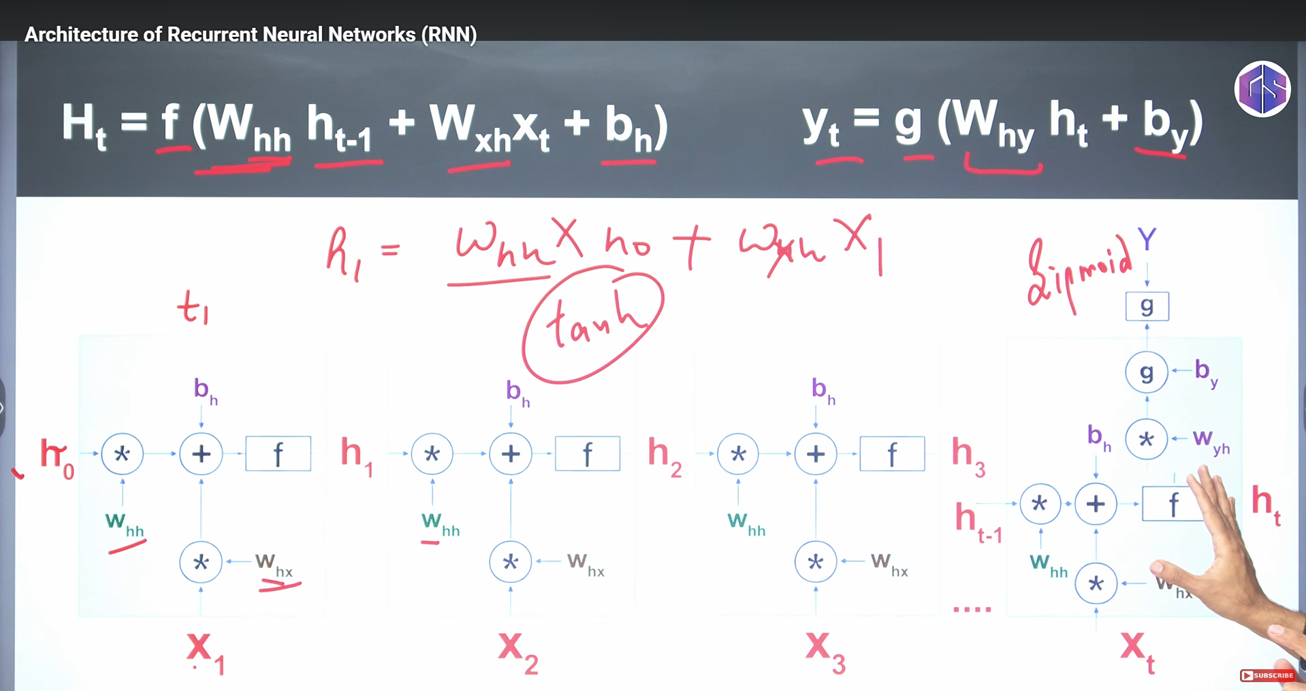
LSTM
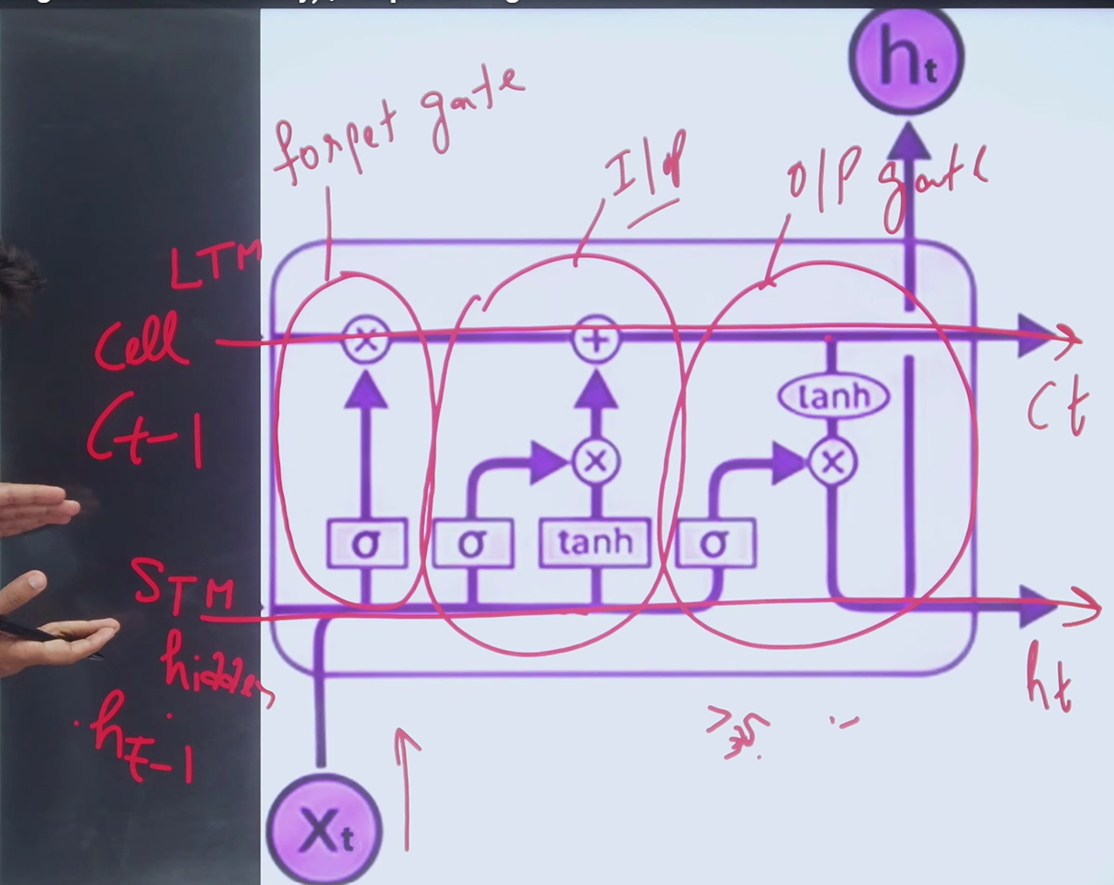
RNN-LSTM-GRU
import numpy as np
from tensorflow.keras.preprocessing.text import Tokenizer #word ko token ma convert krta ha
from tensorflow.keras.preprocessing.sequence import pad_sequences # har sentence ki length diffirent hoti ha
from tensorflow.keras.models import Sequential # sequential model ha layer by layer
from tensorflow.keras.layers import Embedding, LSTM, GRU, Dense, SimpleRNN # layers ha

# dataset
sentences = [
"I love this movie, it's fantastic!",
"I love The film was terrible and boring.",
"Amazing storyline and great acting.",
"I didn't enjoy the movie at all.",
"It was a wonderful experience.",
"The plot was dull and uninteresting.",
"A masterpiece of cinema.",
"I wouldn't recommend this movie.",
"The best film I've seen this year.",
"Absolutely awful, I walked out."
]

# har sentence ko difine kr dena ha ka in ma say positive / Negative
labels=np.array([1, 0, 1, 0, 1, 0, 1, 0, 1, 0])

# sentece ko token ma convert krna or phr un ko numbers assigne krna
tokenizer=Tokenizer(num_words=10000)
tokenizer.fit_on_texts(sentences)
sequences=tokenizer.texts_to_sequences(sentences)
max_length=max([len(seq) for seq in sequences])
padded_sequences=pad_sequences(sequences,maxlen=max_length,padding='post',truncating='post')

model=Sequential()
model.add(Embedding(10000,16,input_length=max_length))
model.add(SimpleRNN(32,return_sequences=True))
model.add(LSTM(32,return_sequences=True))
model.add(GRU(32, return_sequences=False))
model.add(Dense(1,activation='sigmoid'))

model.compile(loss='binary_crossentropy',optimizer='adam',metrics=['accuracy'])
histoyr=model.fit(padded_sequences,labels,epochs=10,validation_split=0.2)
loss,accuracy=model.evaluate(padded_sequences,labels)
print(f"Loss:{loss}")
print(f"Accuracy:{accuracy}")

